Dupont East Civic Action Association
City-wide Coalition on DDOT Bike Plans
Dangerous
by Design
Let’s Greet Brooke Pinto
on the
17th Street BIKE PLAN
Friday, Oct. 1, 3:30-5 pm
At Safeway, 17th & Corcoran Sts.
Ward 2 Councilmember Brooke Pinto will tour
the reckless and dangerous DDOT 17th St. Bike Plan.
For Safety Sake,
Survival of our Livable/Walkable Business Community,
For a Comprehensive Review, Community Engagement, &
A Safe Alternate Route for Bikes
Music by Lorenz Wheatley
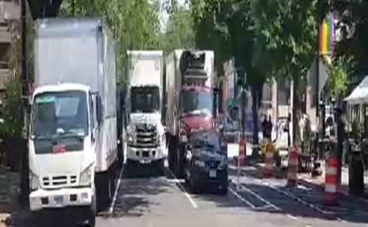

703 929 6656

